ValueOps VSM – VSM for Delivery Leaders (Camille/Candy Company 3) – Creative Brief

Target length: | ~120-180 secs
Media types: | Animation, combined with screenshots/screen caps
Mood: | Existing Camille 1: Valentines Launch video
Context: | Continue the Camille/Candy Company story and explanatory series for Broadcom ValueOps VSM. Introduce a new persona, Stuart (VP Development – representing the Delivery/Engineering Leader persona that reports to Camille, the C-suite persona). This video walks through the “5 Steps to VSM” deck in a light-hearted way, showing the daily interactions that Stuart has with the value stream/VSM platform, and how their capabilities help him succeed.

Demo Narrative/Notes | Voiceover Script | Onscreen/Additional Direction
 | Let’s check in with our global candy company, as they successfully shift to a digital-first model with ValueOps VSM from Broadcom, an enterprise-level value stream management platform.  This is Stuart, Vice President of Development. | Characters: Stuart (VP Development), Rajesh (VP Product), Camille (CDO), persona in reserve  Use the existing background for in-office, and same primary character animations
[Step 1 Identify Value Streams] | He’s part of a unified team with Rajesh, his counterpart in product management, and their Chief Digital Officer, Camille.
[Step 2 – Align with the Business] | Camille: “Based on customer demand, our new priority is to integrate the Augmented Reality app with ecommerce – they really want to buy with one click.”  Stuart: “…well, this is a huge pivot, but it does look like we can deliver this quarter by shifting 50% of our resources….” | 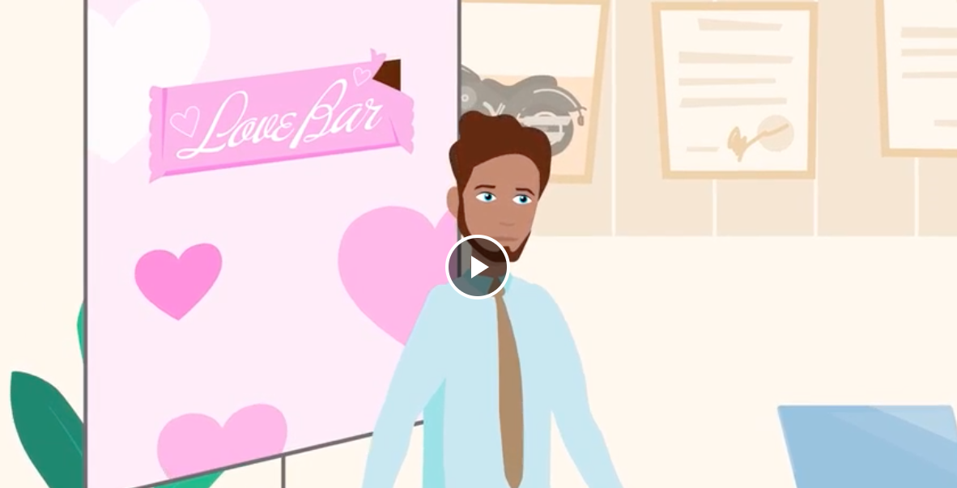  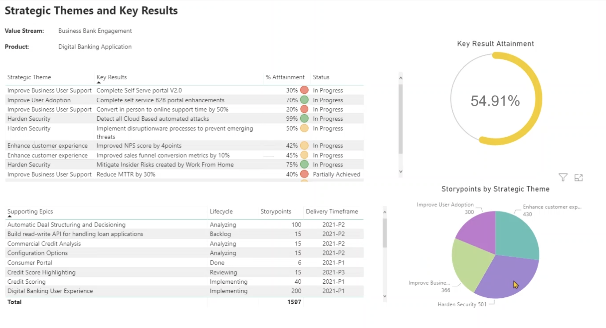
 | ValueOps keeps everyone aligned by providing insights into which work efforts lead to the best outcomes – and what can safely be de-prioritized to make it happen. | 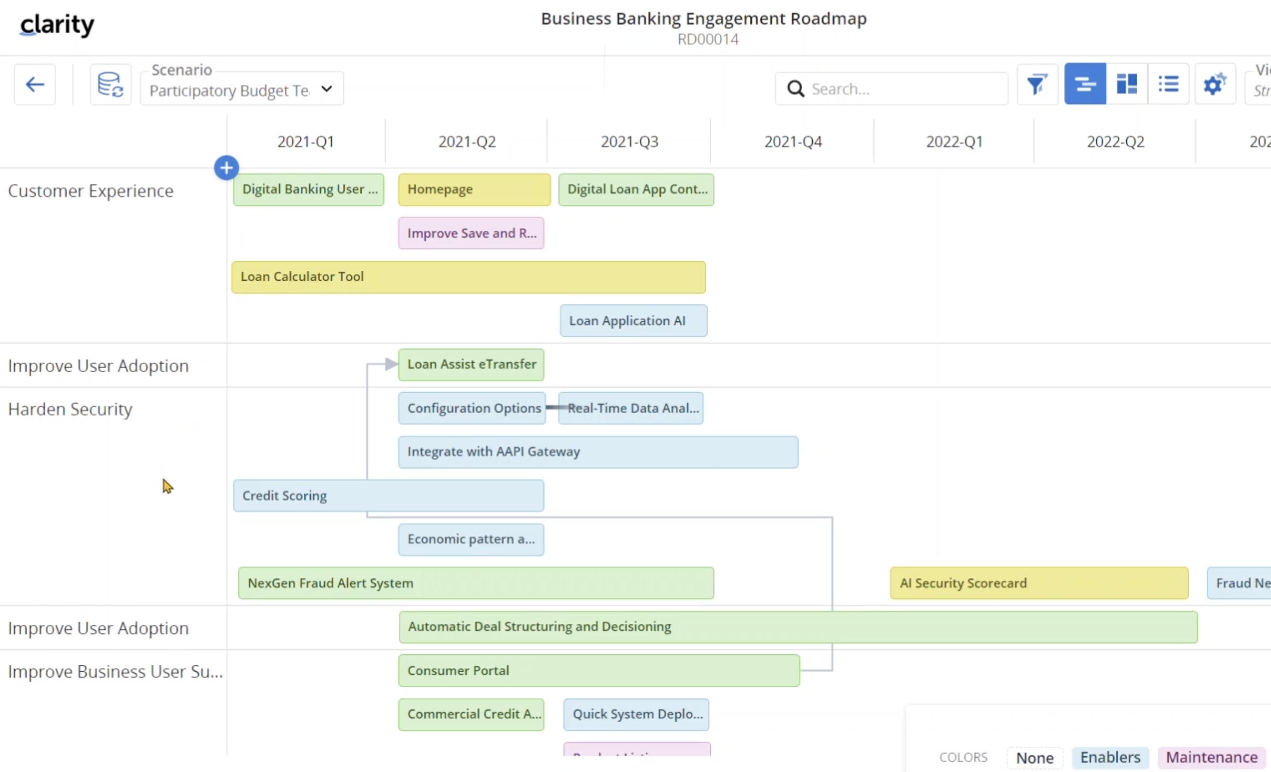
 | In this planning session with Camille and Rajesh, Stuart can visualize their decisions on the roadmap, identify risks and dependencies, and immediately report on the impact they will have on his backlog. | 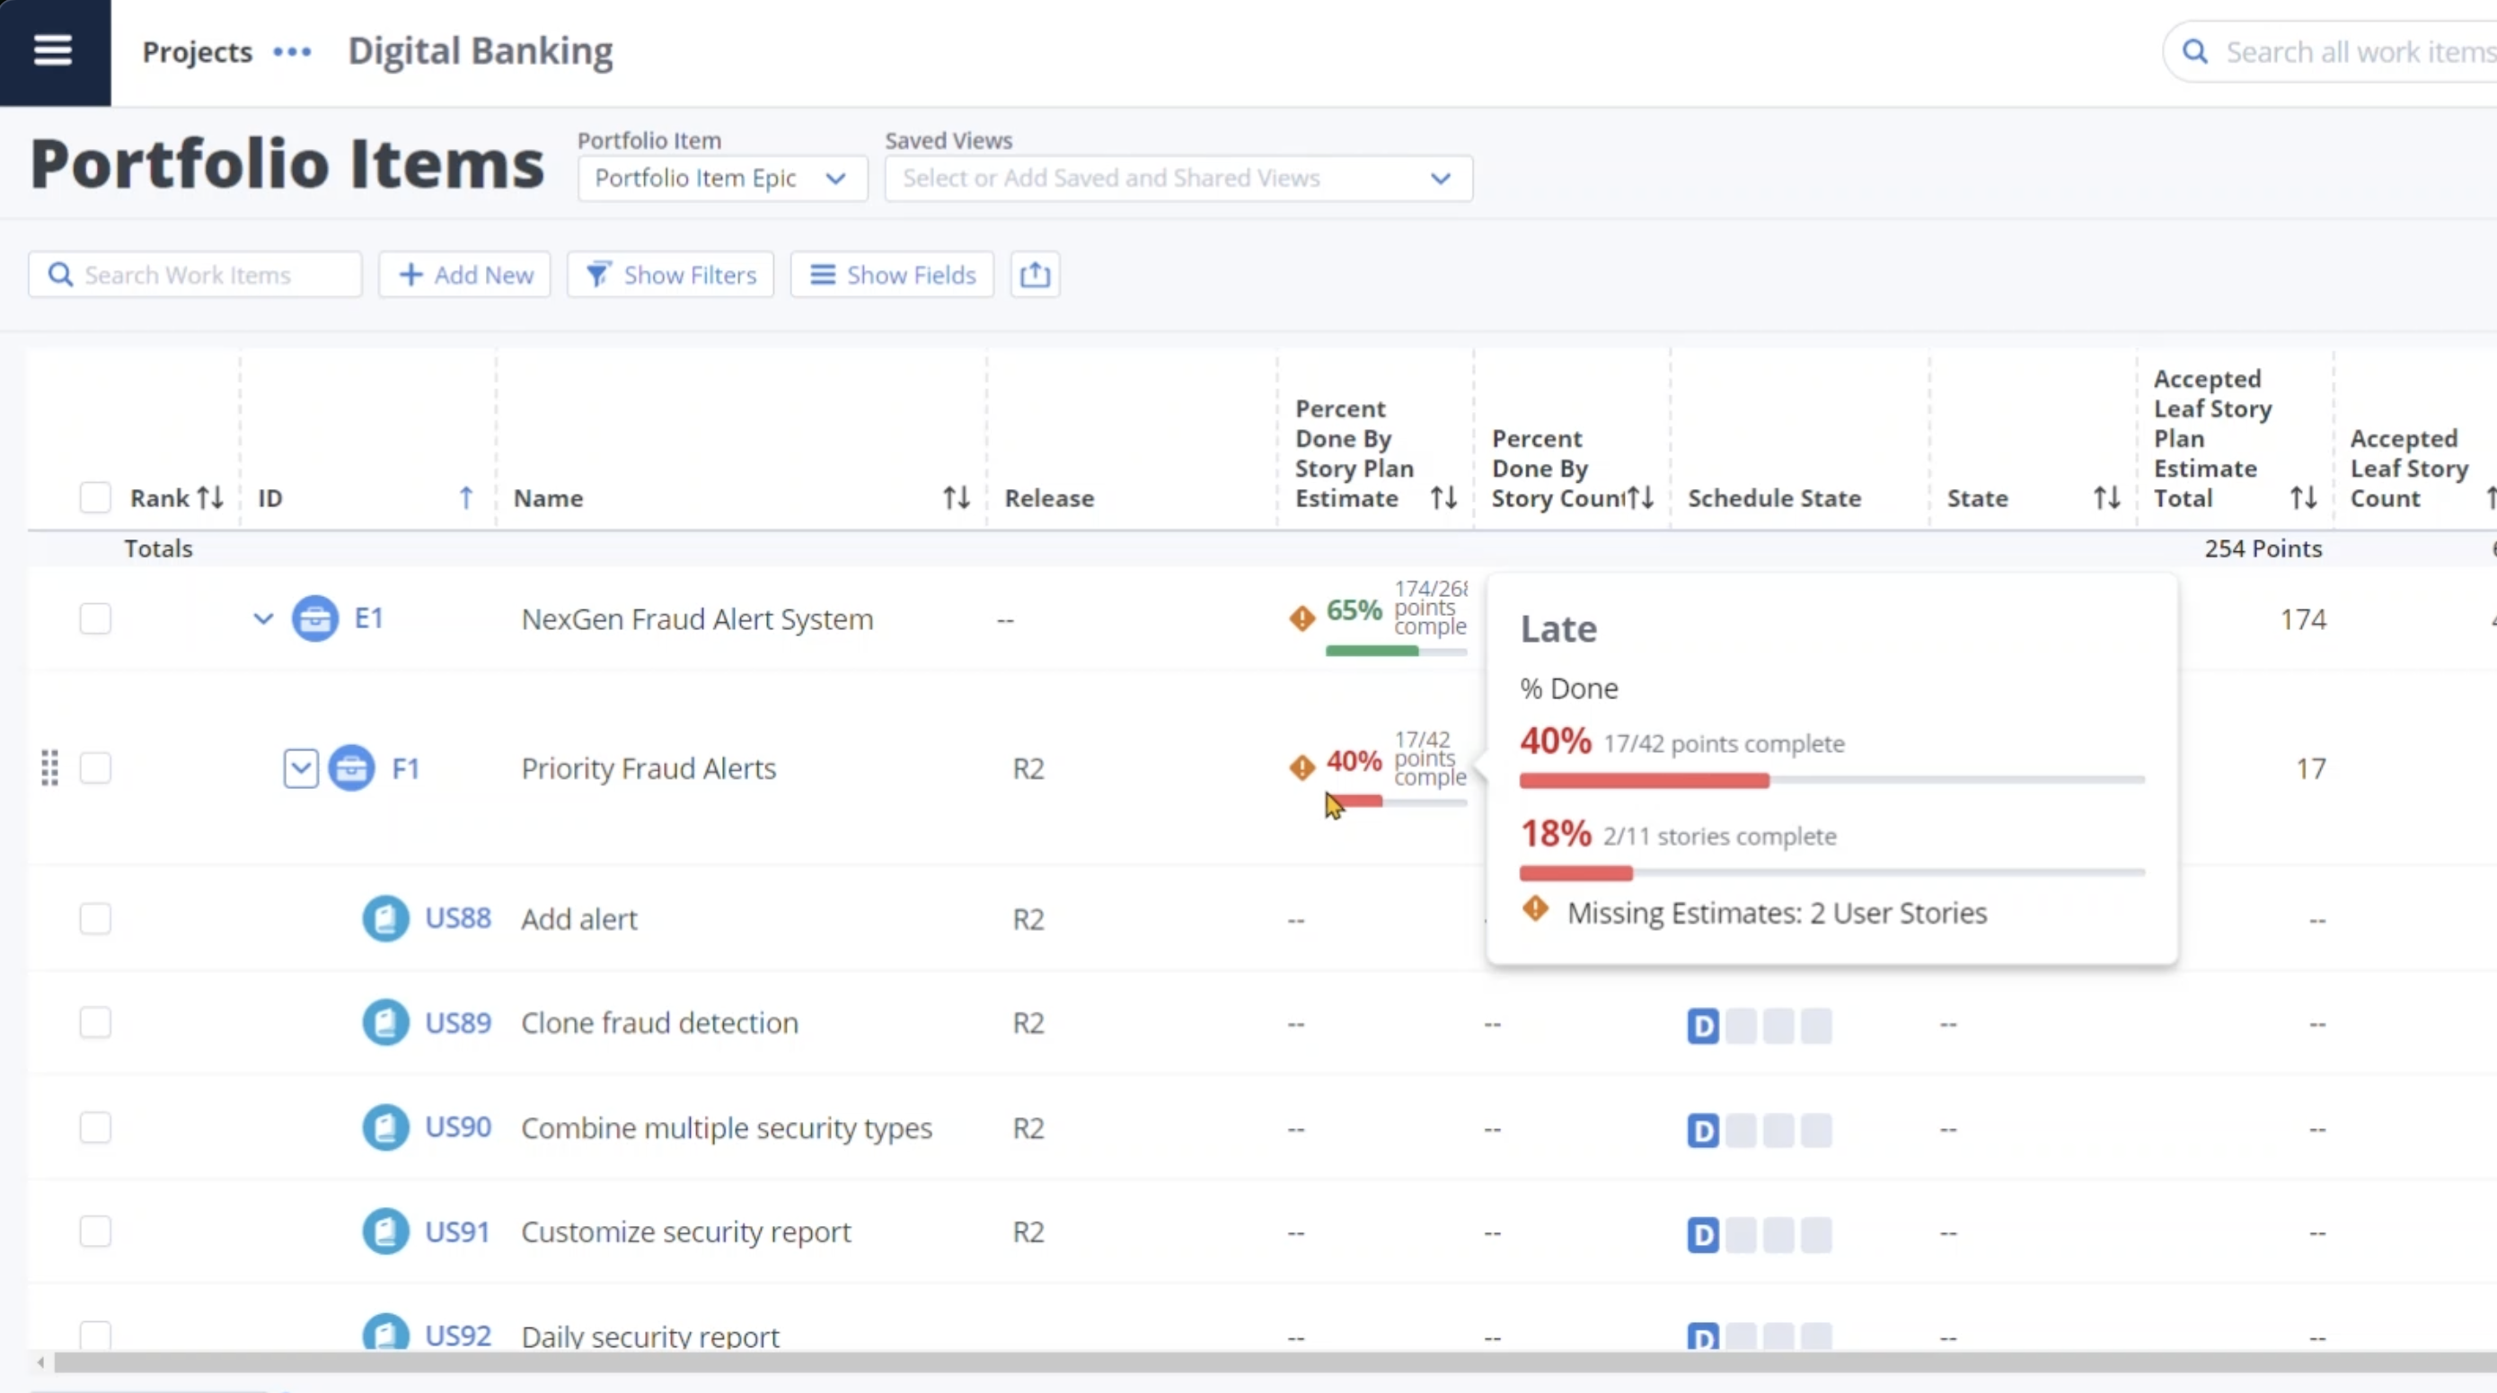
[Step 3 – Rally Your Teams] | Stuart: “by moving the partner portal upgrades out, I can put my best team on this…”  Rajesh: “…and it looks like finishing this integration first might actually make that easier…”  Camille: “This is a great idea, let’s go with it!” | 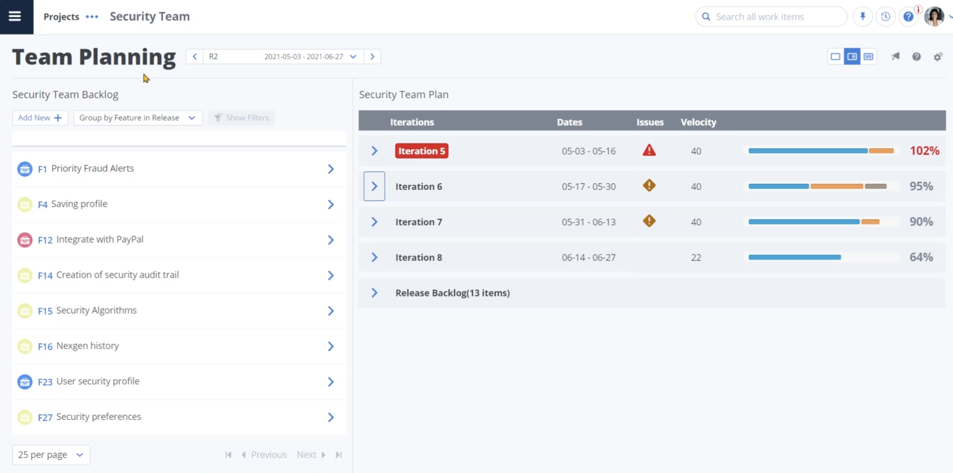
 | Even with his developers scattered around the globe and using different tools, ValueOps easily aggregates their metrics into a single source of truth to help Stuart stay on top of this dynamic situation – so he can build the optimal plan to keep everyone delivering at their best. | 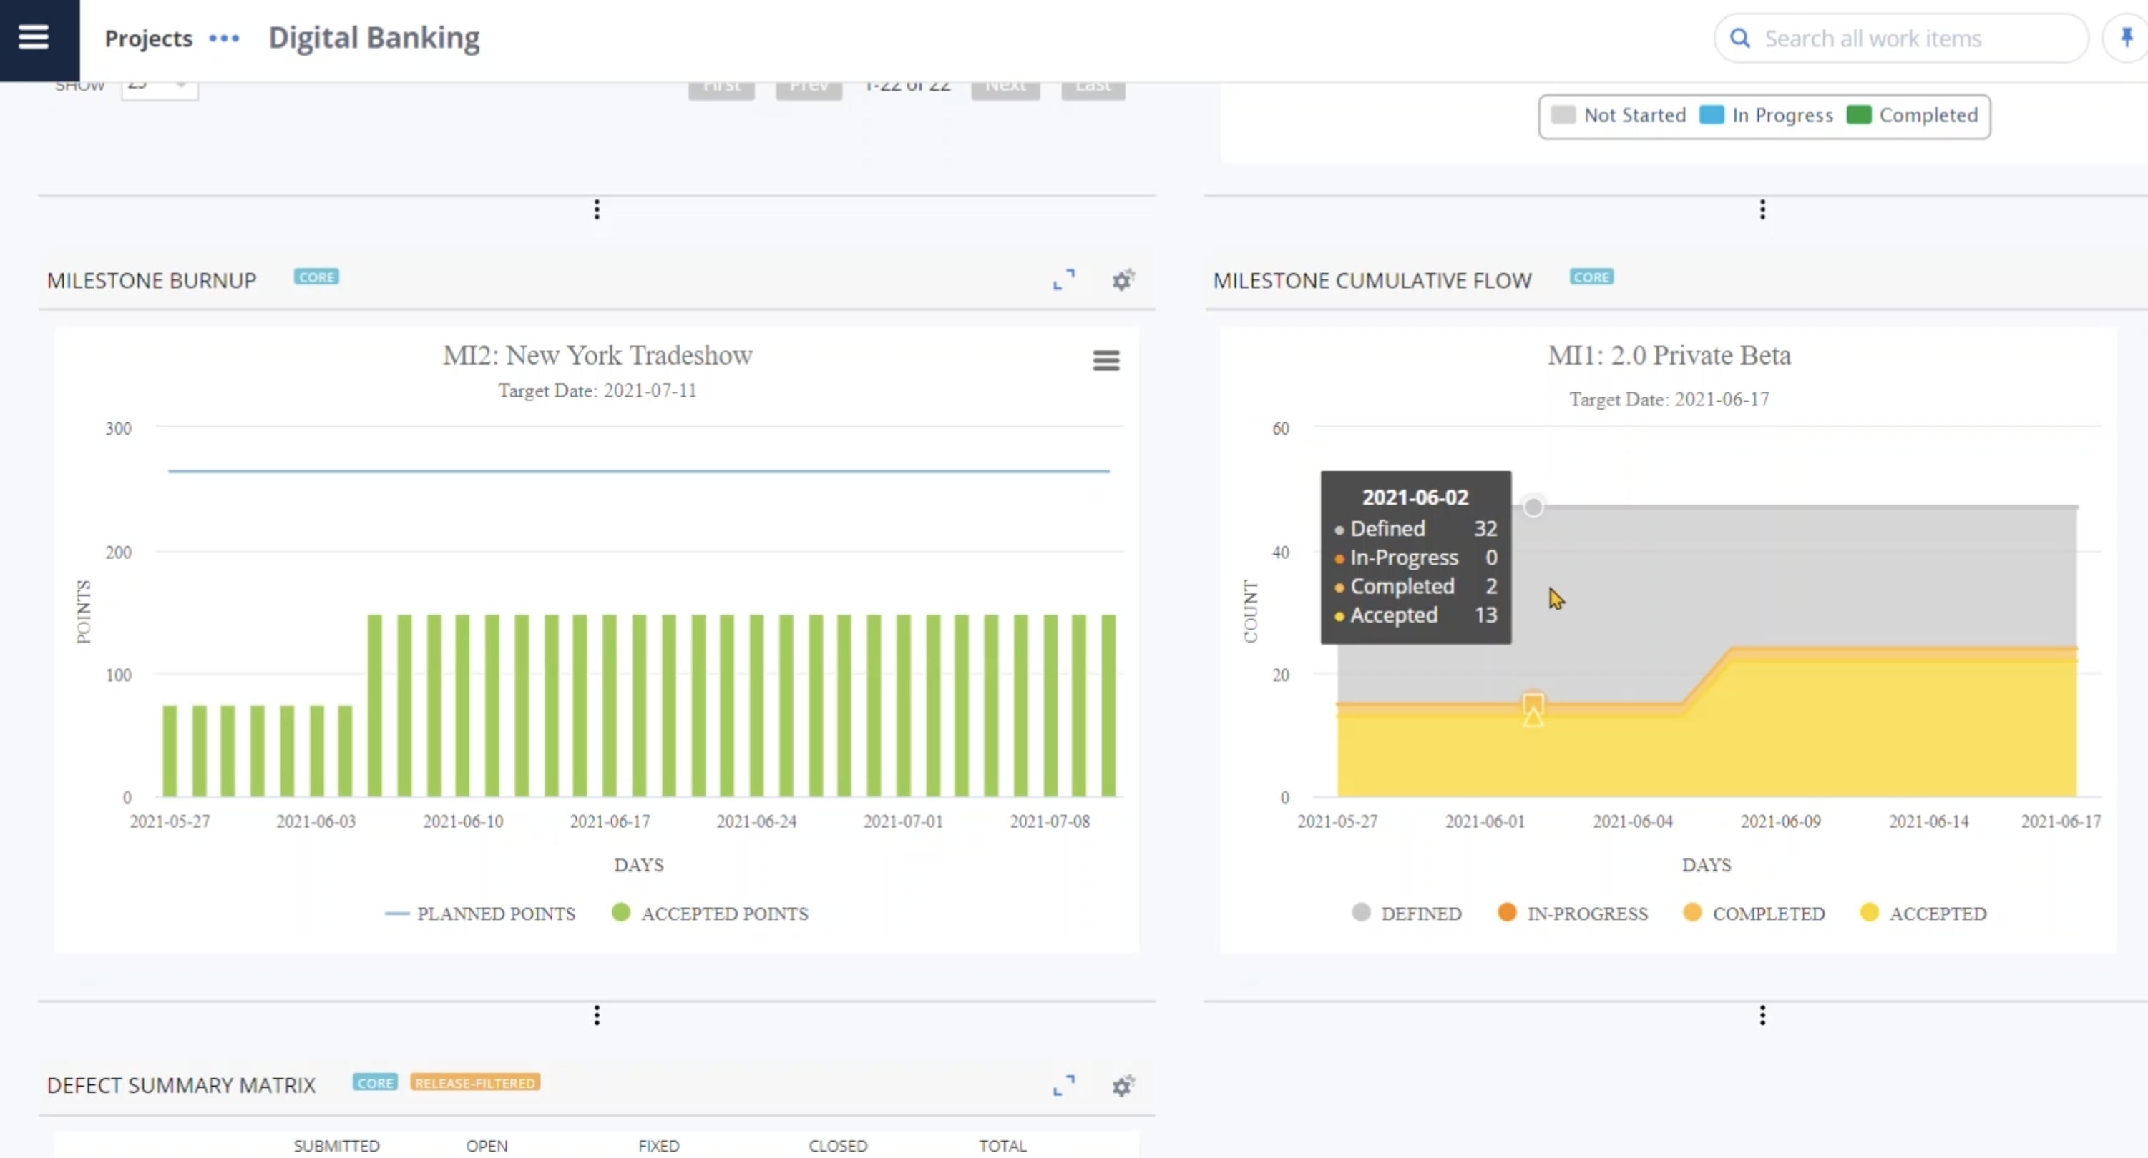
[Step 4 – Execute with Confidence] | The sprints are moving forward, and Stuart orchestrates his teams through multiple dependencies – optimizing flow, and reducing the effect of roadblocks and other challenges. | 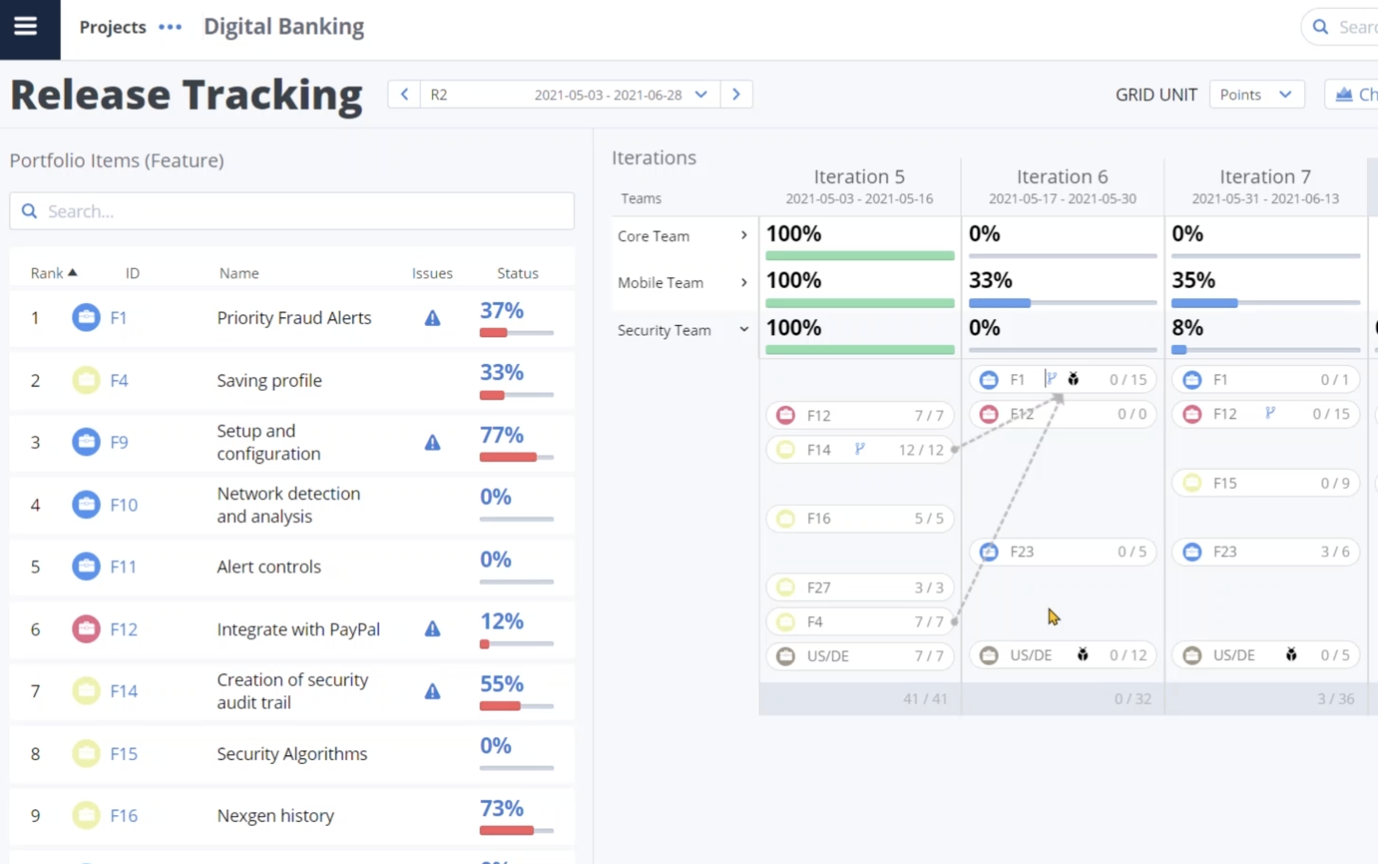
 | Stuart: “Until the security upgrades are made on the ecommerce side, we’re wasting work on this story…”  Rajesh: “…I see that too – let’s move it to the next sprint.” | 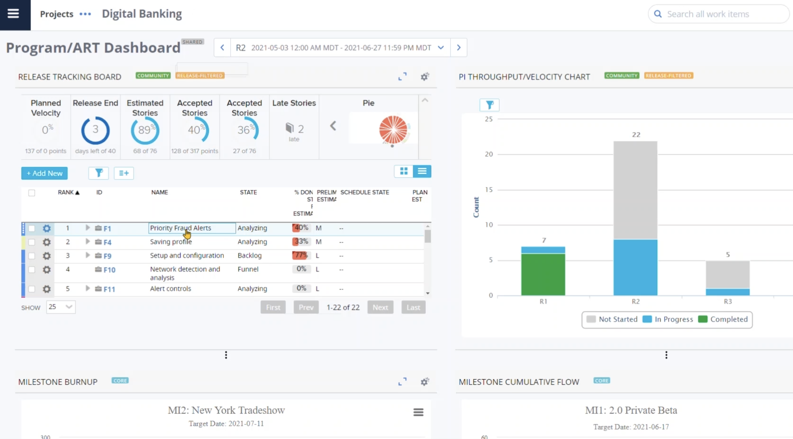
[Step 5 – Evolve and Improve] | Launch Day!  As candy orders flow smoothly through his integration, Stuart holds a review with his developers.  Velocity and quality are both trending up, and thanks to ValueOps, the team is happy to see that every new feature they built is having a positive impact on business performance! | 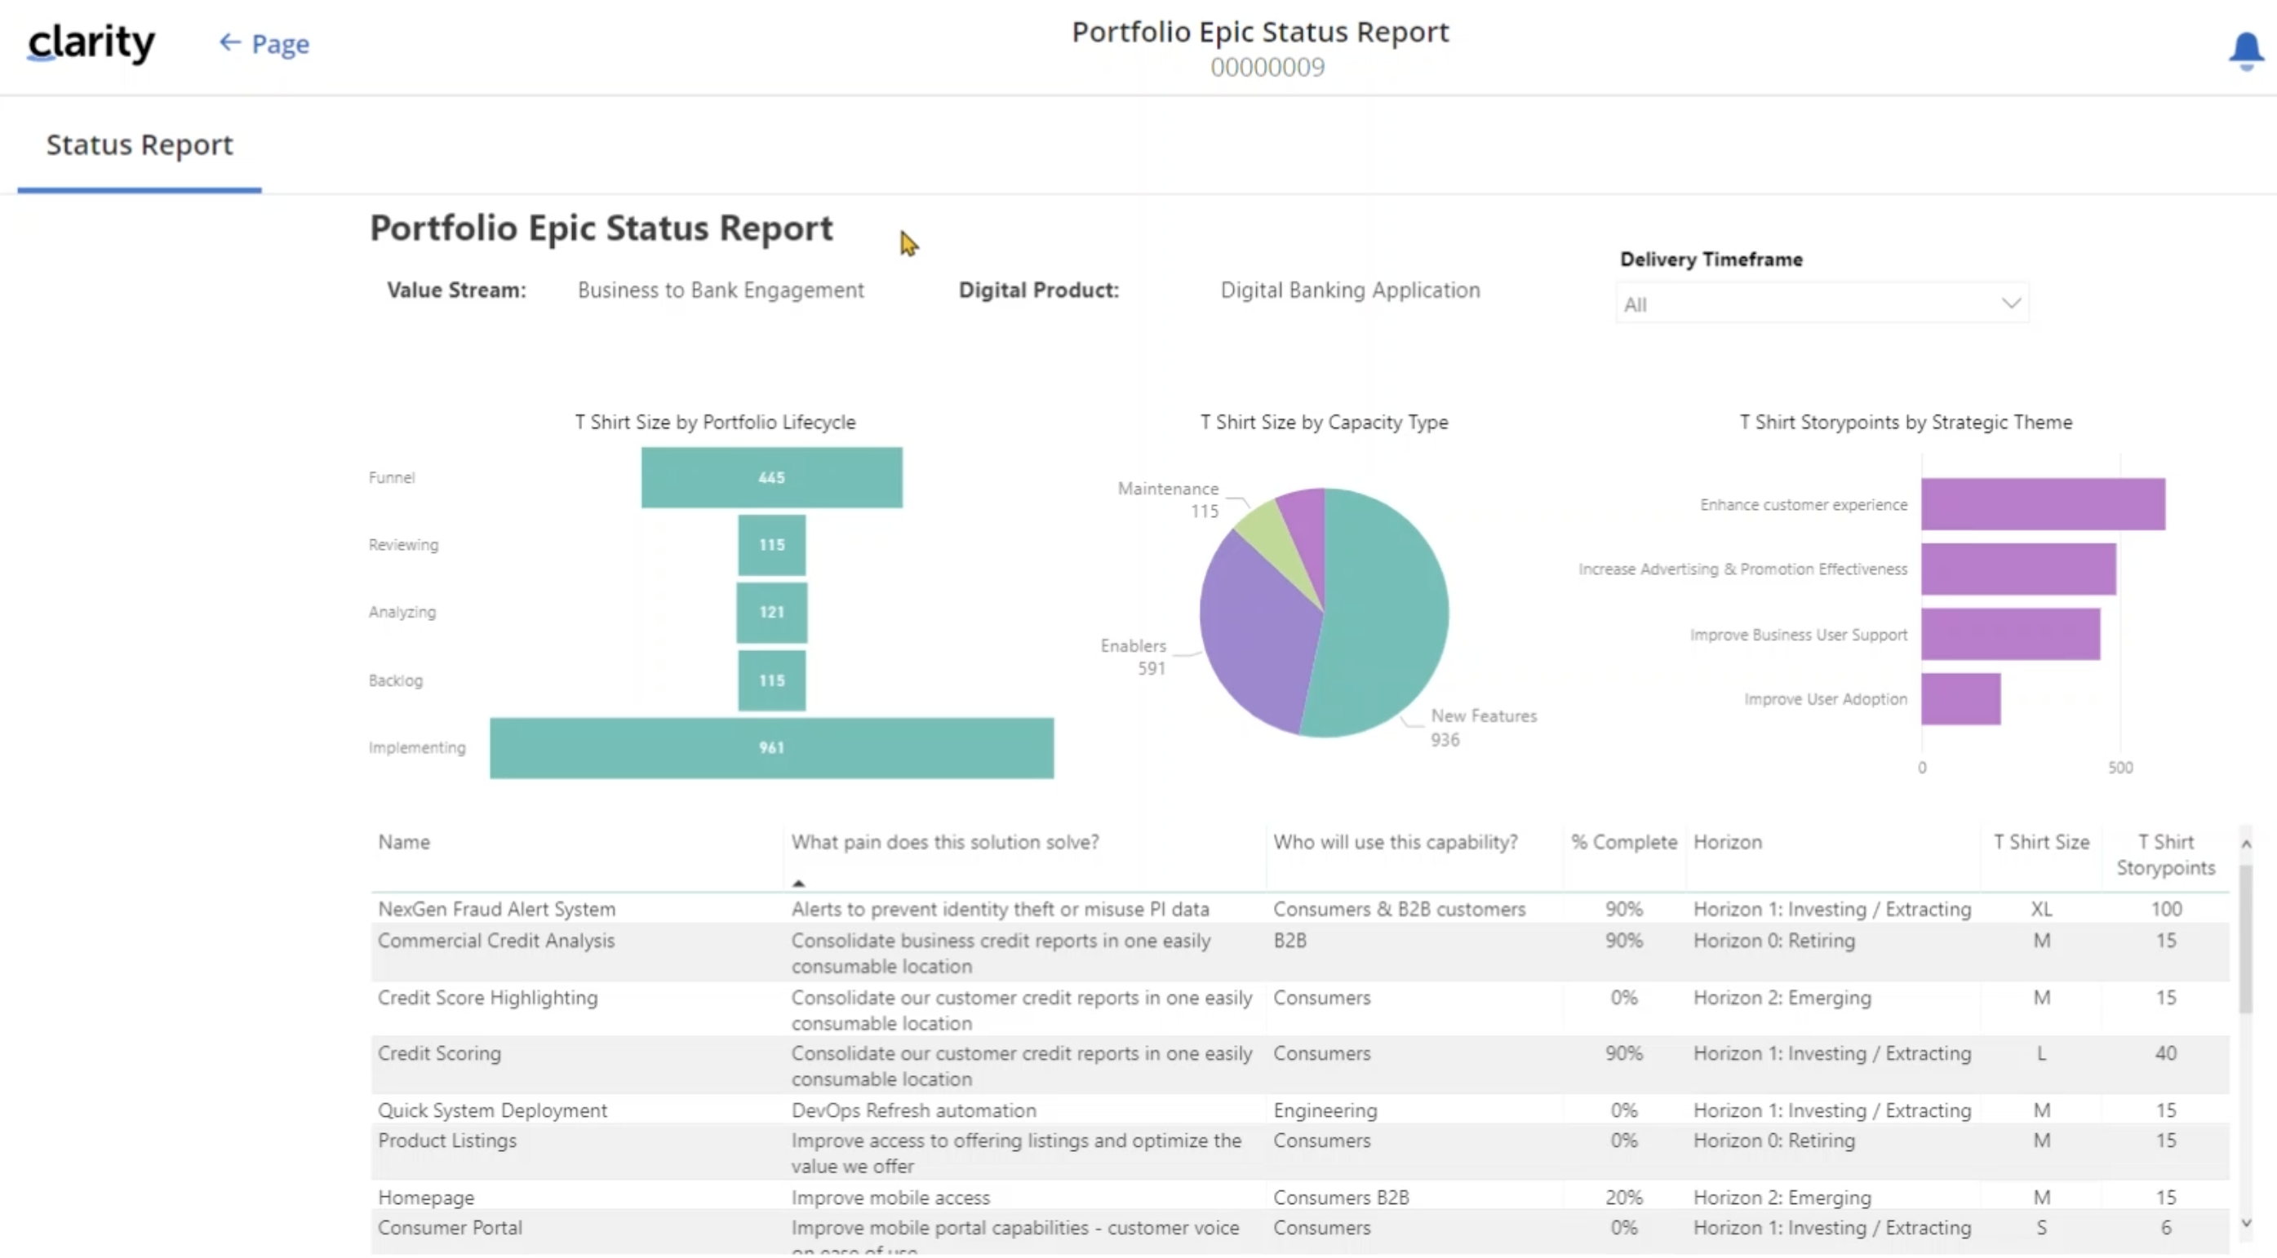
With yet another success under their belts, Camille congratulates everyone – with a special shoutout to Stuart and his developers for once again delivering the most valuable customer priority, without sacrificing quality, performance, or his team’s morale.

Camille: “Thanks again, Stuart – now go and enjoy some time off!”

 | [CTA - Standard ValueOps Contact Bumper] | [CTA - Standard ValueOps Contact Bumper]

